AQI PREDICTION USING MACHINE LEARNING
MINI PROJECT REPORT
Submitted in partial fulfilment of the requirements for the award of the degree of
BACHELOR OF TECHNOLOGY
in
INFORMATION TECHNOLOGY ENGINEERING
by
Sayyam Jain Rohan Khilnani Vasu Bansal
02311503119 00411503119 35311503119
Guided by
Mr. Puneet Singh Lamba
Assoc. Professor



DEPARTMENT OF INFORMATION TECHNOLOGY ENGINEERING BHARATI VIDYAPEETH’S COLLEGE OF ENGINEERING
(AFFILIATED TO GURU GOBIND SINGH INDRAPRASTHA UNIVERSITY,DELHI) DELHI – 110089
MAY 2022

CANDIDATE’S DECLARATION
It is hereby certified that the work which is being presented in the B. Tech Major Project Report entitled "AQI PREDICTION USING MACHINE LEARNING" in partial fulfilment of the requirements for the award of the degree of Bachelor of Technology and submitted in the Department of Information Technology Engineering of BHARATI VIDYAPEETH’S COLLEGE OF ENGINEERING, New Delhi (Affiliated to Guru Gobind Singh Indraprastha University, Delhi) is an authentic record of our own work carried out during a period from January 2022 to May 2022 under the guidance of Mr. Puneet Singh Lamba
The matter presented in the B. Tech Major Project Report has not been submitted by me for the award of any other degree of this or any other Institute.
Sayyam Jain Rohan Khilnani Vasu Bansal
02311503119 00411503119 35311503119
This is to certify that the above statement made by the candidate is correct to the best of my knowledge. He/She/They are permitted to appear in the External Major Project Examination
Mr. Puneet Singh Lamba Dr. Prakhar Priyadarshi
The B. Tech Minor Project Viva-Voce Examination of Sayyam Jain (Enrollment No: 02311503119), Rohan Khilnani (Enrollment No: 00411503119), Vasu Bansal (Enrollment No: 35311503119), has been held on ……………………………….
(Signature of External Examiner)

Mr. Ravi Arora Ms. Anshu Khurana

ABSTRACT

We forecast the air quality of India by using machine learning to predict the air quality index of a given area. Air quality index of India is a standard measure used to indicate the pollutant (SO2, NO2, O3, PM. etc.) levels over a period. We developed a model to predict the air quality index based on historical data of previous years and predicting over a particular upcoming year as a Gradient decent boosted multivariable regression problem. we improve the efficiency of the model by applying hyper parameter optimization in Random Forest Regressor. Our model will be capable for successfully predicting the air quality index. In our model by implementing the proposed parameter- reducing formulations, we achieved better performance than the standard regression models. our model has 98.52% accuracy on predicting the current available dataset on predicting the air quality index of Delhi.
The major pollutants Such as (NO2, SO2, O3) indexes AQI is acquired, with this individual AQI, the data can be categorised based on the limits. We collected the data from the Indian Central Pollution Control Board, which contains pollutant concentration occurring at various places across India.
We start by calculating the individual index of the pollutant for every available datapoints and find their respective AQI for the region. We have designed a model to predict the air quality index of every available data point in the dataset, our model is capable of forecasting the air quality of India in any given area. By predicting the air quality index, we can backtrack the major pollution causing pollutant and the location affected seriously by the pollutant across India. This give more information and knowledge about the cause and seniority of the pollutants.

ACKNOWLEDGEMENT

We express our deep gratitude to Mr. Puneet Singh Lamba Department of Information Technology Engineering for his valuable guidance and suggestion throughout our project work. We are thankful to Mr. Ravi Arora, Ms. Anshu Khurana, for their valuable guidance.
We would like to extend my sincere thanks to Head of the Department, Dr. Prakhar Priyadarshi for his time to time suggestions to complete my project work. We are also thankful to Prof. Dharmender Saini for providing us the facilities to carry out our project work.

Sayyam Jain Rohan Khilnani Vasu Bansal
02311503119 00411503119 35311503119

TABLE OF CONTENTS

CANDIDATE DECLARATION I
ABSTRACT II
ACKNOWLEDGEMENT III
TABLE OF CONTENTS IV
LIST OF FIGURES V
LIST OF ABBREVIATIONS VI
Chapter 1: Introduction
1.1 Introduction
1.2 Motivation
1.3 Objective
1.4 Summary
Chapter 2: Project Description
2.1 About the project
2.2 AQI Prediction Model
2.3 Data Sources
2.4 Pre-processing Data
2.5 Modelling
Chapter 3 : Results and Discussion
3.1 Results and Discussion
Chapter 4 : Conclusion
4.1 Conclusion

LIST OF FIGURES
Figure 1.1:- Yearly Air Quality Index for India
Figure 1.2:- Random forest Regression Tree
Figure 1.3:- Distplot for prediction
Figure 1.4 :- Best parameters for predicting AQI
Figure 1.5 :- Best Results achieved using Random forest regression

LIST OF ABBREVIATION

PM2.5 :- Particulate Matter 2.5
AT :- Absolute Temperature
RH- Relative Humidity
WS- Wind Speed
CO- Carbon Monoxide
NO2-Nitrogen Dioxide
SO2- Sulphur Dioxide
AQI- Air Quality Index

CHAPTER 1: INTRODUCTION

1.0 INTRODUCTION

The Nature is nothing but everything that encircles us. The environment is
getting polluted due to human activities and one of the most common is air
pollution. The concentration of air pollutants in ambient air is governed by the
meteorological parameters such as atmospheric wind speed, wind direction,
relative humidity, and temperature. The major pollutants are Nitrogen Oxide
(NO), Carbon Monoxide (CO), Particulate matter (PM), SO2 etc. Carbon
Monoxide is produced due to the deficient Oxidization of propellant such as
petroleum, gas, etc. Nitrogen Oxide is produced due to the ignition of thermal
fuel: Carbon monoxide causes headaches, vomiting; Benzene is produced due to
smoking, it causes respiratory problems; Nitrogen oxides causes dizziness,
nausea; Particulate matter with a diameter 2.5 micrometre or less than that
affects more to human health. Air Quality Index (AQI), is used to measure the
quality of air. Earlier it was difficult and imprecise to know the quality of air
and was based on predictions but now due to advancement of technology, it is
easy to fetch the data about the pollutants of air using sensors. Assessment of
raw data to detect the pollutants needs vigorous analysis. Convolution Neural
networks, Recursive Neural networks, Deep Learning, Machine learning
algorithms assure in accomplishing the prediction of future AQI so that
measures can be taken appropriately.
Machine learning which comes under artificial intelligence has three kinds of
learning algorithms, they are the Supervised Learning, Unsupervised learning,
Reinforcement learning. In the propose work we will use these all algorithms to
bring more accuracy like supervised learning algorithms such as Linear
Regression, Random Forest.

2.0 MOTIVATION

Several studies, experiments, and research have been approved over the years
to get precise and accurate results for prediction of air quality index using
Machine Learning algorithms, here are the details of some foremost research
papers, thoroughly examined.

Ishan et.al [1] described the benefits of the Bidirectional Long - Short Memory
[BiLSTM] method to forecast the severity of air pollution. The proposed
technique achieved better prediction which models the long term, short term, and
critical consequence of PM2.5 severity levels. In the proposed method prediction
is made at 6h, 12h, 24h. The results obtained for 12h is consistent, but the result
obtained for 6h, and 24h are not consistent. Chao Zhang et.al
[2] proposed web service methodology to predict air quality. They provided
service to the mobile device, the user to send photos of air pollution. The proposed
method includes 2 modules a) GPS location data to retrieve the assessment of the
quality of the air from nearby air quality stations. b) they have applied dictionary
learning and convolution neural network on the photos uploaded by the user to
predict the air quality. The proposed methodology has less error rate compared to
other algorithms such as PAPLE, DL, PCALL but this method has a disadvantage
in learning stability due to this the results are less accurate. Ruijun Yang et.al
[3] used the Bias network to find out the air quality and formed DAG from the
data set of the town called as shanghai. The dataset is dived for the training and
testing model. The disadvantage of this approach is they have not considered
geographical and social environment characteristics, so the results may vary
based on these factors. Madhuri VM et.al
[4] The concentration of air pollutants in ambient air is governed by the
meteorological parameters such as atmospheric wind speed, wind direction,
relative humidity, and temperature. Air Quality Index (AQI), is used to measure
the quality of air. The proposed work is a supervised learning approach using
different algorithms such as LR, SVM, DT and RF. The result show that AQI
prediction obtained through RF are promising which are analysed with results.

3.0 OBJECTIVE

- Objective of the project is to measure air quality index accurately, by predicting
the air quality index, we can backtrack the major pollution causing pollutant and
the location affected seriously by the pollutant.
- With the Machine Learning based forecasting model, various knowledge about the data is extracted using various techniques to obtain heavily affected regions on a particular region(cluster).
- The air quality index is needed to provide a metric for warning citizens about
the dangers of air pollution at varying levels of intensity.
- AQI informs the public about environmental conditions. It is especially useful
for people suffering from illnesses aggravated or caused by air pollution. If AQI
is not taken seriously it can cause damage to nature and human life. Some of the
risk associated with High AQI to humans is lung diseases, such as asthma,
chronic bronchitis, and emphysema.

4.0 SUMMARY OF THE REPORT
In this study, the analysis of air quality dataset has been carried out using various machine learning techniques. The analysis has been performed for the whole dataset. The performance of the models based on all the algorithms have been evaluated based on the Mean Squared Error, Root Mean Squared Error, absolute mean error (AME). It has been observed that Random Forest has the highest accuracy in comparison with other techniques. It has been further observed that the experimental results improve when feature selection methods are used, and all the four models produce good results. Data collection was done, and suitable data analysed to make the best model for better prediction. Earlier the collected data was trained using Linear Regression, and Lasso Regression. Where, Lasso worked better. Now the data was further trained using Decision Tree and Random Forest Regressor among all Random Forest showed the best accuracy.

CHAPTER 2: DESCRIPTION OF PROJECT

2.1 ABOUT THE PROJECT

As the largest growing industrial nation, India is producing record number of pollutants specifically Co2, pm2.5 etc and other harmful aerial contaminants. Air quality of a particular state or a country is a measure on the effect of pollutants on the respected regions, as per the Indian air quality standard pollutants are indexed in terms of their scale, these air quality indexes indicate the levels of major pollutants on the atmosphere. There are various atmospheric gases which causes pollution on our environment.
Each pollution has individual index and scales at different levels. The major pollutants Such as (NO2, SO2, O3) indexes AQI is acquired, with this individual AQI, the data can be categorized based on the limits. We collected the data from the Indian government database, which contains pollutant concentration occurring at various places across India. We start by calculating the individual index of the pollutant for every available datapoints and find their respective AQI for the region. We have designed a model to predict the air quality index of every available data point in the dataset, our model can forecast the air quality of India in any given area. By predicting the air quality index, we can backtrack the major pollution causing pollutant and the location affected seriously by the pollutant across India. With this forecasting model, various knowledge about the data is extracted using various techniques to obtain heavily affected regions on a particular region(cluster). This gives more information and knowledge about the cause and seniority of the pollutants

2.2 AIR QUALITY INDEX PREDICTION MODEL
Fine material (PM2.5) could be a important one as a result of it's a giant concern to people's health once its level within the air is comparatively high. PM2.5 refers to little particles within the air that scale back visibility and cause the air to look hazy once levels are elevated. But in the proposed system we calculate the air quality index of all the pollutants using the AQI formulae to know the air quality level in a particular city using gradient descent and Box-Plot analysis. In the proposed system the air quality index of the upcoming years can be predicted using the present AQI values.

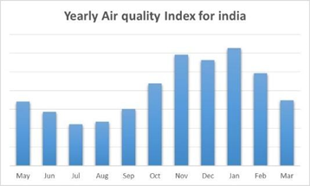
Figure 1.1 :- Yearly Air Quality Index for India

I

2.3 DATA SOURCES
To predict the air quality index of a particular region , we need the pollutant concentration of all the gases which will be available in the cpcb.nic.in website, which holds all the data that pollutes the cities every year. The AQI formulae will be applied to calculate the AQI by using the linear regression algorithm for a particular year. Several datasets will be imported inside the directory and null values will be dropped.

2.4 PRE-PROCESSING THE DATA

In this dataset the outliers are mainly of faulty sensor or transmission errors, these errors have huge variation than the normal valid results. We know the standard range of pollutants occurs on a particular area so to remove the outliers from the data we use boundary value analysis. By using BVA we found the upper quartile range and lower quartile range of a given data

2.5 MODELLING
The Data was trained and tested using various machine learning algorithms Like Linear Regression, Lasso Regression, Extra Tree Regressor, Random Forest and we got our best results with Random Forest Regression.

RANDOM FOREST REGRESSION
Random Forest Regression is a supervised learning algorithm that uses ensemble learning method for regression. Ensemble learning method is a technique that combines predictions from multiple machine learning algorithms to make a more accurate prediction than a single model. 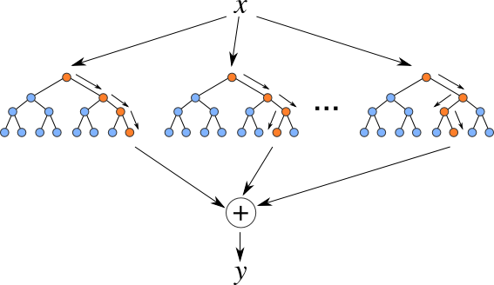
Figure 1.2:- Random forest Regression Tree

We will use the sklearn module for training our random forest regression model, specifically the RandomForestRegressor function. The RandomForestRegressor documentation shows many different parameters we can select for our model. Some of the important parameters are highlighted below:
- n_estimators — the number of decision trees you will be running in the model
- criterion — this variable allows you to select the criterion (loss function) used to determine model outcomes. We can select from loss functions such as mean squared error (MSE) and mean absolute error (MAE). The default value is MSE.
- max_depth — this sets the maximum possible depth of each tree
- max_features — the maximum number of features the model will consider when determining a split
- bootstrap — the default value for this is True, meaning the model follows bootstrapping principles (defined earlier)
- max_samples — This parameter assumes bootstrapping is set to True, if not, this parameter doesn’t apply. In the case of True, this value sets the largest size of each sample for each tree.

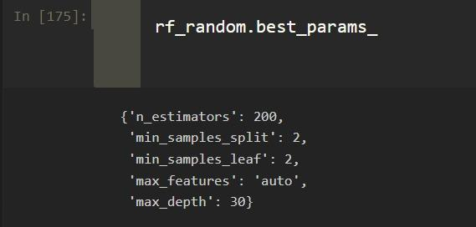
Figure 1.4 :- Best parameters for predicting AQI
ACCURACY MEASURE
For measuring the accuracy of the model built we have used three metrics.
- Root Mean Squared Error: Root mean square error or root mean square deviation is one of the most commonly used measures for evaluating the quality of predictions. It shows how far predictions fall from measured true values using Euclidean distance. Root mean square error can be expressed as
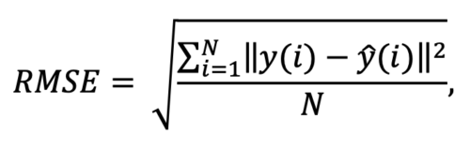
where N is the number of data points, y(i) is the i-th measurement, and y ̂(i) is its corresponding prediction.
- Absolute Mean Error: MAE measures the average magnitude of the errors in a set of predictions, without considering their direction. It’s the average over the test sample of the absolute differences between prediction and actual observation where all individual differences have equal weight.
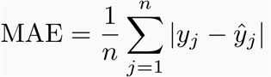
- Mean Squared Error: Mean squared error (MSE) measures the amount of error in statistical models. It assesses the average squared difference between the observed and predicted values. When a model has no error, the MSE equals zero. As model error increases, its value increases. The mean squared error is also known as the mean squared deviation (MSD).
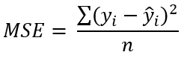

CHAPTER 3: RESULTS AND DISCUSSION
The accuracy for our is Model is 98.52%. The best accuracy has been achieved using random forest regression along with applying the hyperparameter optimization.

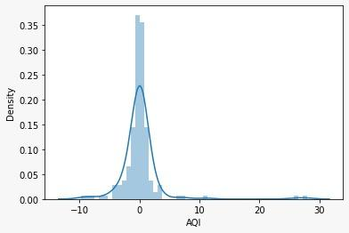
Figure 1.3:-Distplot for prediction
Three Different Scores were calculated for the determination of accuracy of our machine learning model and the following were:
Mean Absolute Error (MAE) – 1.48
Mean Squared Error (MSE) – 12.48
Root Mean Squared Error (RMSE) – 3.53
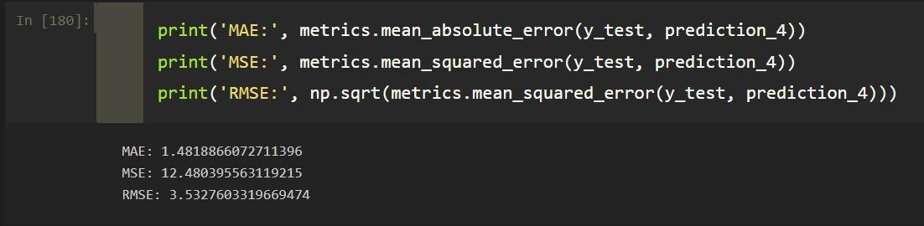
Figure 1.5 :- Best Results achieved using Random forest regression

CHAPTER 4: CONCLUSION
Since our model can predict the current data with 98.52% accuracy it will successfully predict the upcoming air quality index of any data within a given region. With this model we can forecast the AQI and alert the respected region of the country also it a progressive learning model it is capable of tracing back to the location needed attention provided the time series data of every possible region needed attention. The air quality information utilized in this paper originates from the China air quality checking and investigation stage, and incorporates the normal every day fine particulate issue (PM2.5), inhalable particulate issue (PM10), ozone (O3), CO, SO2, NO2 fixation and air quality record(AQI).The essential perspectives that should be viewed as with regards to gauging of the poison focus are its different sources alongside the components that impact its fixation.

REFERENCES

[1] Jasleen Kaur Sethi, Mamta Mittal (2018). A Study of Various Air Quality Prediction Models. Circulation in Computer Science, ICIC 2017, 128-131.
[2] Wang, D., Wei, S., Luo, H., Yue, C., & Grunder,(2017). A novel hybrid model for air quality index forecasting based on two-phase decomposition technique and modified extreme learning machine. Science of The Total Environment, 580, 719-733.
[3] Verma, Ishan, Rahul Ahuja, HardikMeisheri, andLipikaDey. “Air pollutant
severity rediction using Bi-directional LSTM Network.” In 2018
IEEE/WIC/ACM International Conference on Web Intelligence (WI), pp. 651-
654. IEEE, 2018.
[4] Figures Zhang, Chao, Baoxian Liu, Junchi Yan, Jinghai Yan, Lingjun Li,
Dawei Zhang, XiaoguangRui, and RongfangBie. “Hybrid Measurement of Air
Quality as a 5 Fig. 8. RH w.r.t tin oxide Fig. 9. RH w.r.t C6H6 Mobile Service:
An Image Based Approach.” In 2017 IEEE International Conference on Web
Services (ICWS), pp. 853- 856. IEEE,2017.
[5] Yang, Ruijun, Feng Yan, and Nan Zhao. “Urban air quality based on Bayesian
network.” In 2017 IEEE 9th Fig. 10. RH w.r.t NO Fig. 11. RH w.r.t NO2
International Conference on Communication Softwareand Networks (ICCSN),

pp. 1003-1006. IEEE,2017.
[6] Madhuri VM, Samyama Gunjal GH, Savitha Kamalapurkar “Air Pollution
Prediction Using Machine Learning Supervised Learning Approach” In 2020
international journal of scientific and technology research volume 9
pp. ISSN 2277-8616
[7] Kumar, Anikender and P. Goyal, “Forcasting of daily air quality index in
Delhi”, Science of the Total Environment 409, no. 24(2011): 5517- 5523.

